Gunnedah Baptist Community Preschool
Reservoir St GUNNEDAH
PO Box 95 GUNNEDAH NSW 2380
Phone 6742 1805
ABN 33 003 052 328
Email: gdhbaptistpreschool@bigpond.com
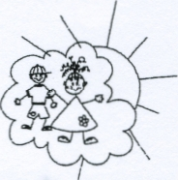

Dear Families,
As way of communicating with families and sharing our day, each room have their own private Facebook page.
This page will used to keep you informed of your child’s day including photos, excursions, special events and spontaneous moments. This page will also invite parent feedback and inclusion. The posts will be private, not of general publication and only available to the families of that room.
Please circle the appropriate Yes or No response to;
Give permission to include you in the group Yes No
Give permission for your child’s Christian name and initial of their surname to be used Yes No
Give permission for your child’s photo to be displayed on the page Yes No
Commit to keeping comments respectful and constructive Yes No
Make a commitment not to share photos from the page that include other children Yes No
………………………………..…………………… (print your name ……………………………………(signature)
……………………………………… (date)
Thank you for your response
Julie Frend

